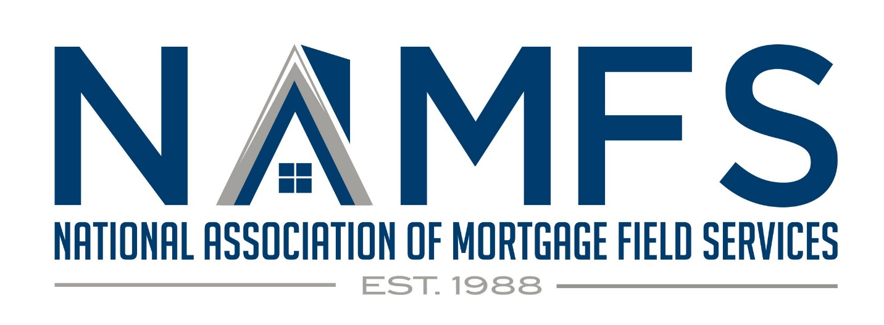

PRESS RELEASE August 26, 2021

The National Association of Mortgage Field Services (NAMFS) is pleased to announce a new strategic partnership with Gate House Strategies, LLC. The goal of this partnership is to address the unique challenges and critical policy issues that impact the mortgage field services industry. Many of these issues have been longstanding and change is necessary for the industry to thrive, ensure market sustainability, and ensure homes and properties are appropriately preserved and protected.

In conjunction with this partnership, NAMFS was honored to have Brian Montgomery, Chairman & Founding Partner, of Gate House Strategies, LLC speak at our 2021 Virtual Conference this August. During his remarks as the Keynote Speaker, Brian shared the following, “We look forward to working with you and the industry through NAMFS, our firm is very excited about it. We look forward to strengthening relationships and building upon those that NAMFS has nurtured to find greater success together.”

NAMFS was founded in 1988 with the stated mission of providing its membership with a voice to all parties within the Mortgage Field Services Industry. In our 33 years of existence, NAMFS has been a key voice and participant in shaping our industry. Selective accomplishments include:

- Participated in creation of the MBA Type 1 & 2 Inspection Forms,
- Provided technical direction, guidance, and best business practices to shape investor and government guidelines and regulations,
- Partnered to create an industry standard background check,
- Led efforts to identify our industry as an essential business during the COVID19 pandemic,
- Created technology standards for photos and video,
- Created an industry standard PCR (property condition report) which was shared with MISMO,
- Delivered alternative guidelines and pricing for clearboarding of windows.

“As the oldest and largest Mortgage Field Service Trade Association, NAMFS believes it was incumbent to be a leader in finding solutions to the challenges the industry is facing today and in the future. Many of the issues we have identified are longstanding in nature and have become untenable due to a convergence of issues. Our primary goal and focus will be to better the mortgage field services industry. The collaboration with Gate House Strategies is the next exciting chapter for NAMFS.” said Matt Zoldowski, NAMFS President.

NAMFS views this effort as critical to the sustainability of the mortgage field services industry and looks forward to a successful partnership with Gate House Strategies, LLC.

ABOUT NAMFS
The National Association of Mortgage Field Services, Inc. (NAMFS) is the premier trade association for the mortgage field service industry. We are dedicated to working with all entities of the industry from the government agencies and investors that set policy, to the contractors and inspectors that perform the work.

ABOUT Gate House Strategies, LLC
Gate House Strategies is a Washington, DC area-based advisory firm focused within the Mortgage Lending/Servicing, Community Development, and Public Housing sectors, providing both private and public sector clients with strategic insights, actionable intelligence, policy-making know-how, and current perspective to achieve results in today's changing environment.

